**BUGS in NLP Suite**

Stanford CoreNLP 1

Error 1: Illegal character % 1

Error 2: Connection refused 1

Read line (corpus statistics) 2

Bug fixed 3

# Stanford CoreNLP

## Error 1: Illegal character %

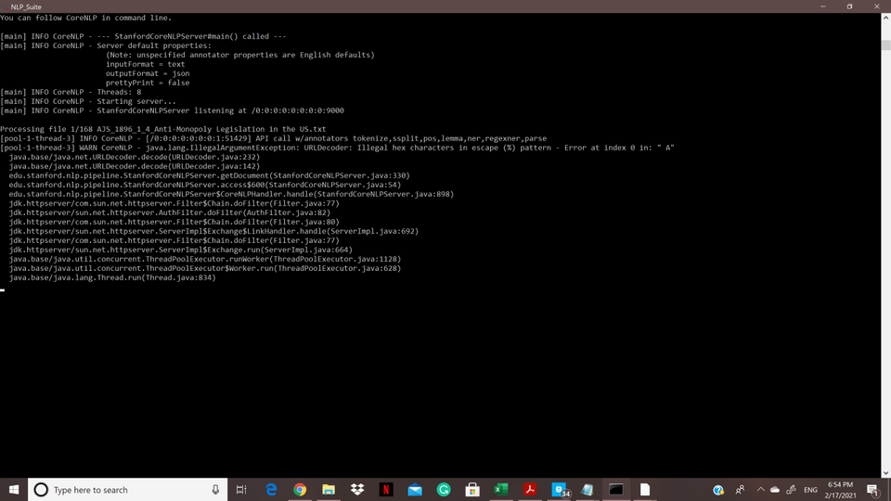

## Error 2: Connection refused

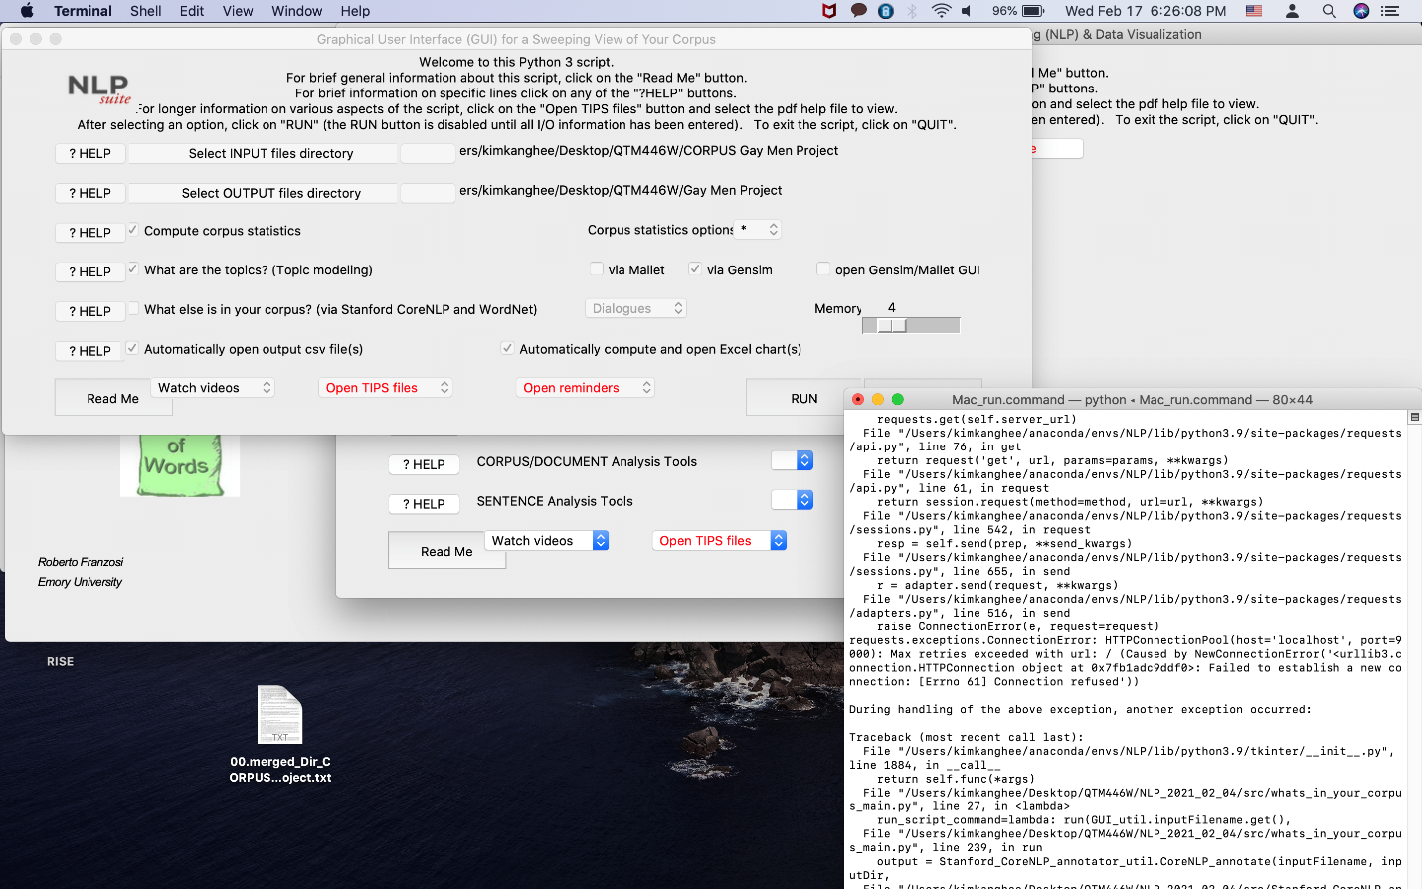

Error 3:

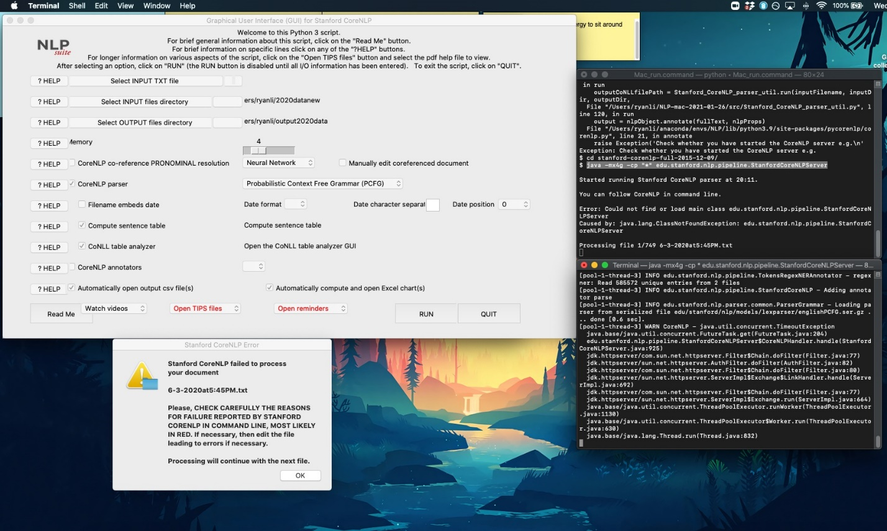

# Read line (corpus statistics)

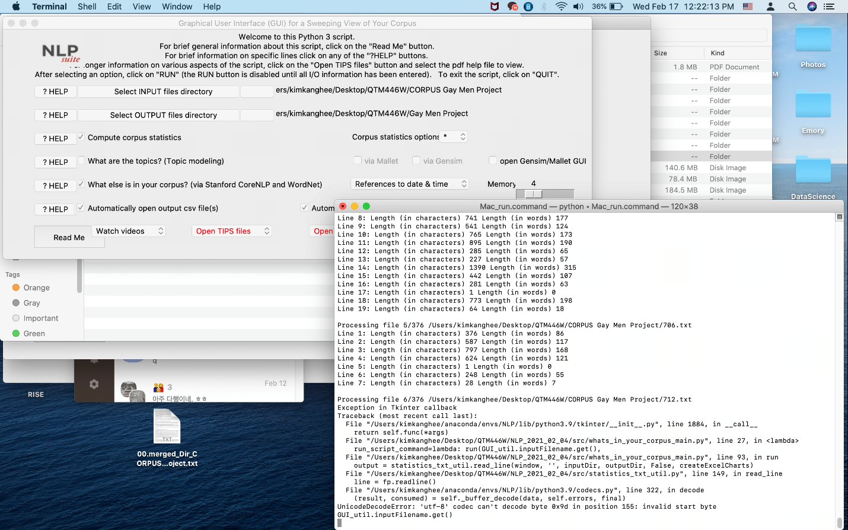

## Bug fixed